P40 SPS THRUSTING

PURPOSE: - To control the GNCS during countdown, ignition, thrusting and thrust termination of a GNCS controlled SPS maneuver.
- To compute a preferred IMU orientation and a preferred attitude for a SPS thrusting mnvr, or to calculate and display the gimbal angles wich would result with the present IMU orientation.
- To do the vehicle mnvr to the thusting attitude.
ASSUMPTION: The target parameters have been calculated and stored in the CMC by prior execution of a pre-thrusting program.
REMARK: The mnvr may be performed with:
- The present IMU orientation if the MGA (Yaw axis) is not greater than 45° & the IMU has been realigned within the last 3 Hrs.
- A new orientation achieved by selection of P52 (P54).

Prethrust Program Complete (P30's)
CMC & ISS - on
Cycle CRYO FANS (pnl 2)
SYSTEM pg. 5 step 11
SCS - OPERATING
TEST C/W LAMPS
Perform EMS ΔV TEST & NULL (pnl 1)
BIAS CHEK, pg G/2-5
Set ΔVC
EMS FUNC - ΔV
SPS GAUGING - AC1 (pnl 4)
PUG MODE - NORMAL (pnl 3)
OXID PLOW vlv - PRI
SM/AC PWR - on (up) (pnl 181)
BMAG MODE (3) - RATE 2 (pnl 1)
CMC MODE - FREE
AUTO RCS SELECT (16) - as req'd (pnl 8)
LOAD DAP (check roll jets)
V48,V46
ROT CONTR PWR NORM (2) - AC/DC (pnl 1)
Set DET

1 MNVR TO PAD BURN ATT (if burn att known)
SC CONT - CMC (pnl 1)
CMC MODE - AUTO
V49E

2 PERFORM BORESIGHT & SXT STAR CHECK
V41 N91E

3 V37E 40E

4 F 50 18 REQUEST MNVR TO FDAI RPY ANGLES (.01°)
(AUTO) BMAG MODE (3) - RATE 2 (pnl 1)
SC CONT - CMC
CMC MODE - AUTO
PRO

5 06 18 AUTO MNVR TO FDAI RPY ANGLES (.01°)

6 F 50 18 REQUEST TRIM MNVR TO FDAI RPY ANGLES
ALIGN S/C ROLL
GDC ALIGN see pg 7-X (to be written)

TVC CHECK & PREP
cb STAB CONT SYS (all) - close (Pnl 8)
cb SPS (12) - close
EMS FUNC - ΔV (verify) (pnl 1)
MAN ATT (3) -RATE CMD
ATT DB - MIN
RATE - LOW
TRANS CONT PWR - ON
SCS TVC (2) - RATE CMD
ΔVCG - LM/CSM or CSM
TVC GMBL DRIVE P&Y - AUTO (verify)

+54:00m MN BUS TIE (2) - ON (pnl 5)
(-06:00) TVC SERVO PWR #1 - AC1/MNA (pnl 7)
TVC SERVO PWR #2 - AC2/MNB
BMAG MODE (3) - ATT1/RATE 2 (pnl 1)

+55:00m PRIMARY TVC CHECK (TBD)
(-05:00) GMBL MOT P1-Y1 - START/ON(up) (pnl 1)

SEC TVC CHECK (TBD)
GMBL MOT P2-Y2 - START/ON(up) (pnl 1)
ROT CONT PWR NORM (2) - AC/DC
ROT CONT PWR DIRECT (2) -MNA/MNB
(TRIM) BMAG MODE (3) - RATE 2
PRO
BMAG MODE (3) - ATT1/RATE 2 (verify)
ENTR

7 F 50 25 00204 GMBL TEST OPTION
(ACCEPT) SC CONT - CMC (VERIFY)
PRO

Monitor GPI Response:
00,02,-02,00,02,-02,00, Trim
*TEST FAIL: *
*SC CONT - SCS *
*SCS TVC (2) - AUTO*

(REJECT) ENTR

8 06 40 TFI, VG, ΔVM (min-sec,.1fps)
*PROG ALARM - TIG Slipped*
*V5N9E 01703 *
*KEY RLSE TO 8 *

FDAI SCALE - 5/5
RATE - HIGH
UPDATE DET
SPS he vlvs (2) - AUTO (verify)
Check N2 A and N2 B

58:00
(-02:00) ΔV THRUST A(B) - NORMAL (guarded) (pnl 1)
THC - ARMED (key /)
RHC (2) - ARMED
TAPE RCDR - HBR/RCD/FWD/CMD RESET (pnl 3)

59:25
(-00:35) DSKY BLANKS

59:30 (AVE G ON)
(-00:30) EMS MODE - NORMAL (pnl 1)

06 40 TFI,VG, ΔVM (min-sec,.1fps)
CHECK PIPA BIAS <2fps for 5 sec

59:XX ULLAGE
(-00:XX)
*If no ULLAGE: *
* DIR ULLAGE PB - PUSH*
* Control att with RHC *

MONITOR ΔVM (3) COUNTING UP

59:55
(-00:05)
F 99 40 ENG ON ENABLE REQUEST
(AUTO IGN) PRO AT TFI > 0 sec
(BYPASS IGN) ENTR to 11 (Perform switching in 10)
EXIT - V37E 00E

9 00:00 IGN *IF SCS : THRUST PB - PUSH*

06 40 TFC,VG, ΔVM (min-sec,.1fps,.1fps)

*F 97 40 SPS Thrust fail *
*ΔV-THRUST B(A)- NORMAL *
*(RESTART) PRO to IGN *
*(RECYCLE) ENTR to TIG-05sec*

SPS THRUST Lt - ON
00:03 ΔV THRUST B(A)- NORMAL
*IF SCS : +X & THRUST PB - PUSH*
MONITOR THRUSTING
Pc 95-105 psia
EMS COUNTING DOWN
SPS INJ VLVS (4) - OPEN
SPS He vlvs tb-gray
SPS FUEL/OXID PRESS - 170-195 ps ia
PUGS - BALANCED

00:XX ECO

10 F 16 40 TFC (STATIC), VG, ΔVM (min-sec,.1fps)
ΔV THRUST A&B - OFF (pnl 1)
VERIFY THRUST OFF
SPS INJ VLVS (4) - CLOSED
SPS He vlvs tb (2) - bp
GMBL MTRS (4) - OFF (LMP Confirm) (pnl 1)
TVC SERVO PWR 1&2 - OFF (pnl 7)
MN BUS TIE (2) - OFF (pnl 5)
PRO

11 F 16 85 VG XYZ (CM) (.1fps)
NULL RESIDUALS
RECORD ΔV COUNTER & RESIDUALS ΔVC____
EMS FUNC - OFF VGX____
EMS MODE - STBY VGY____
RHC & THC - LOCKED VGZ____
ATT DB - MAX (pnl 1)
TRANS CONT PWR - OFF
ROT CONTR PWR DIRECT (2) - OFF
BMAG MODE (3) - RATE 2
cb DIRECT ULLAGE (2) - open (pnl 8)
cb SPS P1 & Y1 - open
PCM BIT RATE - LOW (pnl 3)
MAP CAMR ON - OFF
PAN CAMR PWR - OFF
SM/AC PWR - OFF
PRO

12 F 37 V82E

13 F 16 44 HA,HP,TFF (.1nm,min-sec)
PRO

14 F 37 00E

SPS VERSUS RCS CRITERIA

CSM ONLY
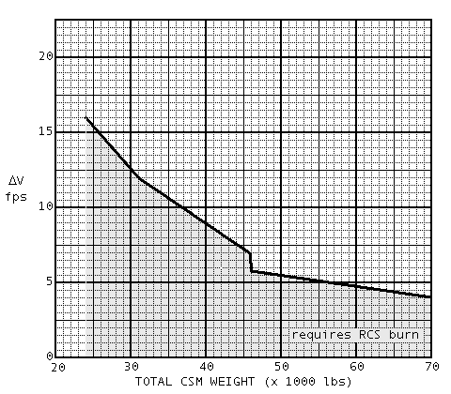

CSM/LM DOCKED
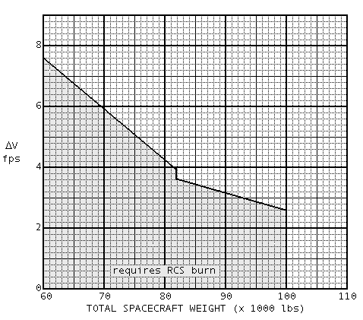

P41 RCS THRUSTING

PURPOSE: - To compute a preferred IMU orientation and a preferred vehicle attitude for an RCS thrusting maneuver
- To do the vehicle mnvr to the thusting attitude.
- To provide suitable displays for manual execution of the thrusting mnvr.
ASSUMPTIONS: - The target parameters have been calculated and stored in the CMC by prior execution of a pre-thrusting program.
- Engine ignition may be slipped beyond the established TIG if desired by the crew or if integration can not be completed on time.
REMARK: The mnvr may be performed with:
- The present IMU orientation if the MGA (Yaw axis) is not greater than 45° & the IMU has been realigned within the last 3 Hrs.
- A new orientation achieved by selection of P52 (P54).

Prethrust Program Complete
CMC - on
ISS - on
SCS - OPERATING
TEST C/W LAMPS (pnl 2)
Perform EMS ΔV TEST & NULL
BIAS CHEK, pg G/2-5
Set ΔVC
EMS FUNC - ΔV (pnl 1)
BMAG MODE (3) - RATE 2
CMC MODE - FREE
AUTO RCS SELECT (16)-as req'd (pnl 8)
LOAD DAP (check roll jets)
ROT CONTR PWR NORMAL (2) - AC/DC (pnl 1)
ROT CONTR PWR DIRECT (2) - MNA/B
Set DET
V37E 00E
SC CONT - CMC/AUTO

1 MNVR TO PAD BURN ATTITUDE (if burn att known)
V49E

2 PERFORM BORESIGHT & SXT STAR CHECK
V41 N91E

3 V37E 41E
(TFI available via N40, N45 or N35)

4 F 50 18 REQUEST MNVR TO FDAI RPY ANGLES (.01°)
(AUTO) BMAG MODE (3) - RATE 2
SC CONT - CMC/AUTO
PRO

5 06 18 AUTO MNVR TO FDAI RPY ANGLES (.01°)

6 F 50 18 REQUEST MNVR TO FDAI RPY ANGLES (.01) (AUTO TRIM) BMAG MODE (3) - RATE 2
ALIGN SC ROLL
SC CONT - CMC/AUTO
PRO
MAN ATT (3) - RATE CMD
ATT DB - MIN
RATE - LOW
BMAG MODE (3) - ATT1/RATE 2
GDC ALIGN see pg 7-3
ENTR

7 06 85 VG X,Y,Z (.1fps)

*PROG alarm lt *
*V5N9E - 01703 - TIG SLIPPED*
*KEY RLSE To 7 *

55:00
(-05:00) TRANS CONT PWR - on (up)
HAND CONTROLLERS - ARMED

59:25
(-00:35) DSKY BLANKS

59:30
(-00:30)

8 16 85 VG X,Y,Z (AVE G ON)
TAPE RCDR - HBR/RCD/FWD/CMD RESET (pnl 3)
LIMIT CYCLE - OFF (pnl 1)
EMS MODE - NORMAL

00:00
9 F 16 85 VG X,Y,Z
NULL COMPONENTS
RECORD ΔV COUNTER & RESIDUALS ΔVC____
EMS FUNC - OFF VGX____
EMS MODE - STBY VGY____
RHC & THC - LOCKED VGZ____
TRANS CONT PWR - OFF
ROT CONTR PWR DIRECT - OFF
BMAG MODE (3) - RATE 2
TAPE RCDR - off (ctr) (pnl 3)
PCM BIT RATE - LOW
PRO

10 F 37 V82E

11 F 16 44 HA,HP,TFF (.1nm,min-sec)

PRO

12 F 37 00E

P47 Thrust Monitor Program

PURPOSE: To monitor vehicle acceleration and to display ΔV during a non GNCS controlled thrusting maneuver.
ASSUMPTION: This program should be turned on just prior to the planned thrusting mnvr and terminated as soon as possible in order to keep error of BIAS and average G at minimum.

CMC - on
ISS - on & aligned

1 V37E 47E
F 16 83 ΔV XYZ (CSM) (.1fps)
*VI,HDOT,H available by N62E*
*KEY RLSE to return to N83 *

(RECYCLE) V32E
(TERM) PRO

2 F 37 00E

